1. General description

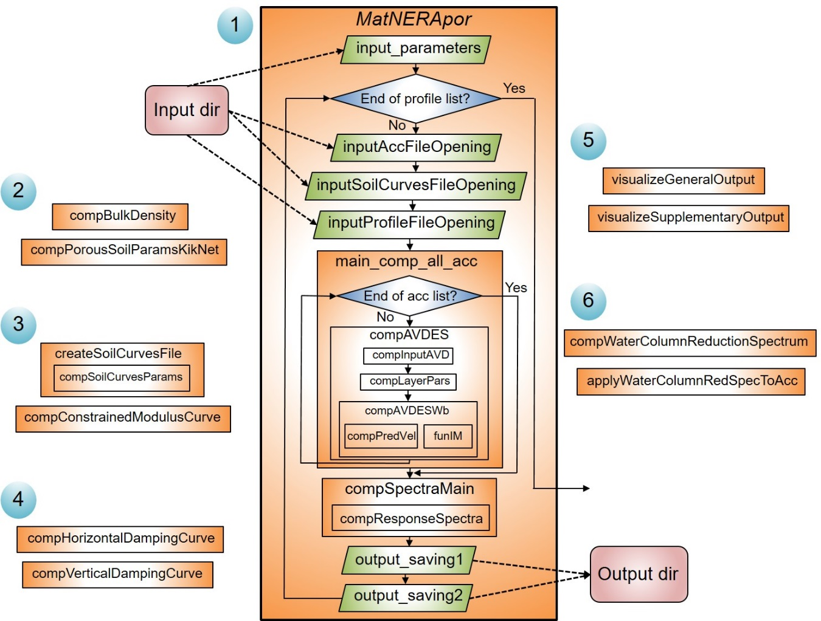

**Figure 1.** Block-scheme of MatNERApor Matlab package for numerical modeling of nonlinear response of porous saturated soil deposits to seismic body waves propagation. Numbers in blue circles - subsets of the package.

The MatNERApor package consists of the set of Matlab scripts and functions. Figure 1 shows the block-scheme of the package containing several subsets:

Subset 1 – a core of earthquake site response computing;

Subset 2 – a toolkit for calculating the bulk density of porous soil and various parameters of porous soil from velocity profiles for the Kik-net sites;

Subset 3 – a toolkit for calculating constrained moduli degradation curves above and under water table and creating an input file with set of soil moduli degradation curves;

Subset 4 – a toolkit for calculating damping curves for P- and SH-wave cases;

Subset 5 – a toolkit for visualizing general and supplementary output;

Subset 6 – a toolkit for calculating theoretical reduction spectra for vertical component due to the water column of different thickness above the site, simulation this reduction by the set of digital Butterworth bandpass filters and applying them to accelerograms.

2. Brief description of functionality of each script and function

Each script or function file contains the brief description of its functionality and input/output parameters.

*Subset 1*:

MatNERApor.m – the main script to run the calculation of site response;

input_parameters.m – the script to set global input parametes and paths with input files;

inputAccFileOpening.m – the script to open and read the file with input set of accelerograms;

inputSoilCurvesFileOpening.m – the script to open and read the file with soil moduli curves;

inputProfileFileOpening.m – the script to open and read the file with soil profile;

main_comp_all_acc.m – the script to calculate site response for particular input profile;

compAVDES.m – the function to calculate iterations for acceleration, velocity, displacement, strain, stress in soil, bedrock motion, bedrock velocity for time increments, sublayer parameters;

compInputAVD.m – the function to calculate acceleration, velocity, displacement in bedrock from input acceleration, remove linear trend, compute bedrock velocity and bedrock displacement, and convert to required units;

compLayerPars.m – the function to calculate sublayer parameters;

compAVDESWb.m – the function to calculate motion for time increments between time steps;

compPredVel.m – the function to calculate predicted velocity;

funIM.m – the function to calculate stress-strain curves of IM model;

compSpectraMain.m – the script to calculate average and single response spectra for all layers and all input accelerograms;

compResponseSpectra.m – the script to calculate response spectra;

output_saving1.m – the script to save .txt file for top and bottom layers general output;

output_saving2.m – the script to save .txt file with output summary and .mat files with general and supplementary output.

*Subset 2*:

compBulkDensity.m – the script to calculate bulk density of porous saturated soil for chosen case;

compPorousSoilParamsKikNet.m – the script to calculate parameters of porous saturated soil for given velocity profile of the Kik-net site.

*Subset 3*:

createSoilCurvesFile.m – the script to create file with the curves of shear and tangential shear moduli and shear resistance;

compSoilCurvesParams.m – the script to calculate curves of shear and tangential shear moduli and shear resistance;

compConstrainedModulusCurve.m – the script to calculate constrained modulus reduction curve and other moduli for chosen case.

*Subset 4*:

compHorizontalDampingCurve.m – the script to calculate damping curve for given G/Gmax curve;

compVerticalDampingCurve.m – the script to calculate damping curve for given M/Mmax (M*/M*max) curve.

*Subset 5*:

visualizeGeneralOutput.m – the script to visualize general output: acceleration, velocity, displacement time histories or stress-strain plot for particular number of input accelerogram and number of sublayer;

visualizeSupplementaryOutput.m – the script to visualize supplementary output: average or single response spectra.

*Subset 6*:

compWaterColumnReductionSpectrum.m – the script to calculate theoretical reduction spectrum for vertical component due to the presence of water column above the site and the corresponding set of Butterwoth filters objects to simulate this reduction;

applyWaterColumnRedSpecToAcc.m – the script to apply the set of Butterwoth filters to input accelerogram to simulate reduction of spectrum for vertical component due to the presence of water column above the site.

**3. How to run the subsets**

*3.1. Running earthquake site response computing (Subset 1)*

*3.1.1. Assigning global input parameters and input files*

Open the script **input_parameters.m** and specify (according to the default example in the file):

- full name of the file with input set of accelerograms;

- full name of the file with input set of soil moduli curves;

- path to the directory with files with input soil profiles;

- time step of input accelerograms in seconds;

- number of subnodes for each sublayer (default and tested value is 30);

- damping (fraction, default value is 0.05);

- full name of the file with input spectral periods vector (for response spectra calculation);

- path to the directory with output;

- full name of file with summary output .txt file (if such a file does not exist, it will be created automatically).

The default values of input parameters in the **input_parameters.m** file correspond to the example input dataset stored in the **input** folder. The **input** and **output** folders must exist.

Subfolder **Acc** contains an example input MAT-file *M60R10.mat* with a set of 5 synthetic accelerograms [cm/s/s] created by the method [Sabetta and Pugliese, 1996] and corresponding to a magnitude M = 6.0 and a hypocentral distance 10 km. A set of accelerograms is a cell array of individual vectors with acceleration time histories.

Subfolder **Profiles** contains two example input MAT-files with synthetic soil profiles:

*ProfileClayeySoilOnFlysh.mat* corresponds to clayey soil layer on flysh bedrock;

*ProfileSandySoilOnFlysh.mat* corresponds to sandy soil layer on flysh bedrock.

These files contain a matrix with following columns:

1-st: depths to top of layers (in meters);

2-nd: number of sublayers for each layer (1 sublayer for each 0.5 m is recommended);

3-rd: bulk density (in kg/m^3);

4-th: compression wave velocity for vertical motions, shear wave velocity for horizontal motions (in m/s);

5-th: number of moduli degradation curve for each later (the number must match the number contained in the file with these curves (*ModuliCurvesSandClayRock.mat*), see below).

Subfolder **ModuliCurves** contains an example input MAT-file *ModuliCurvesSandClayRock.mat* with a set of 3 matrices (1-st matrix – for bedrock [Schnabel et al., 1972]; 2-nd matrix – for clayey soil [Sun et al., 1988], PI = 20-40; 3-rd matrix – for average-scale sandy soil [Seed and Idriss, 1970]), each containing the following columns:

1-st: deformation values (fraction);

2-nd: G/Gmax or M/Mmax (M*/M*max) values (G – shear modulus, M – constrained modulus for unsaturated soil, M* – constrained modulus for saturated soil);

3-rd: H/Gmax values (H – tangential modulus);

4-th: R/Gmax values (R – shear resistance);

To calculate M/Mmax (M*/M*max), H/Gmax and R/Gmax curves using given G/Gmax curve, use the **compConstrainedModulusCurve.m** and **compSoilCurvesParams.m** scripts. Then, to create an input file with a set of moduli curves, use **createSoilCurvesFile.m** script. These scripts are described below.

An example input MAT-file *SpectralPeriodsForRS.mat* contains a vector with spectral periods for response spectra calculation.

*3.1.2. Running response calculations*

After setting global input parameters and input files in the **input_parameters.m** script, run the MatNERApor.m script. Calculations will take some time depending on the number of set of input accelerograms, as well as the size and number of ground profiles. As soon as the calculations are completed, the Matlab command window will display the elapsed time in seconds.

The output is stored in the **output** folder that must be previously created and specified in the **input_parameters.m** script.

*3.1.3. Reading the output*

As soon as the calculations are completed, the **output** folder will contain txt-file with summary of calculations and a subfolder for each input soil profile with corresponding name. These subfolders contain txt-files with time histories of acceleration, velocity and displacement for top and bottom layers, and a txt-file with corresponding averaged response spectra. In addition, they contain MAT-files with general output (*general_output.mat*) and supplementary output (*sup_output.mat*).

The *general_output.mat* file contains a cell array with acceleration in g (general_output{1} cell), velocity in cm/s (general_output{2} cell), displacement in cm (general_output{3} cell), stress in Pa (general_output{4} cell) and strain in % (general_output{5} cell) vectors for each time step and each sublayer.

The *sup_output.mat* file contains a cell array with individual and averaged response spectral acceleration, velocity and displacement vectors, their maximum values and corresponding spectral period values:

sup_output{1} = spectral accelerations in cm/s^2 for each input accelerogram and each sublayer (here and below numbering from the surface);

sup_output{2} = spectral velocities in cm/s for each input accelerogram and each sublayer;

sup_output{3} = spectral displacements in cm for each input accelerogram and each sublayer;

sup_output{4} = average spectral accelerations in cm/s^2 for each sublayer;

sup_output{5} = average spectral velocities in cm/s for each sublayer;

sup_output{6} = average spectral displacements in cm for each sublayer;

sup_output{7} = average peak ground acceleration in cm/s^2 for each sublayer;

sup_output{8} = maximum average spectral acceleration in cm/s^2 for each sublayer;

sup_output{9} = maximum average spectral velocity in cm/s for each sublayer;

sup_output{10} = maximum average spectral displacement in cm for each sublayer;

sup_output{11} = period of maximum average spectral acceleration in seconds for each sublayer;

To visualize output data, use **visualizeGeneralOutput.m** and **visualizeSupplementaryOutput.m** scripts. These scripts are described below.

*3.2.* *Running calculation of bulk density of porous soil and various parameters of porous soil from velocity profiles for the Kik-net sites (Subset 2)*

One can calculate bulk density of porous saturated soil using the **compBulkDensity.m** script for chosen case:

1) Soil consists of soil grains and porous water;

2) Soil consists of soil grains, porous water and gas;

3) Soil consists of soil grains, porous water, ice and gas (or gas mixture).

Corresponding value must be assigned to the *your_case* parameter, as in default example. Then, input porous parameters must be set in if-elseif-end structure. Input and output are described in the script file.

In addition, one can calculate parameters of porous saturated soil for given velocity profile of the Kik-net site using the **compPorousSoilParamsKikNet.m** script. Input and output are described in the script file.

*3.3. Running calculation of constrained moduli degradation curves above and under water table and creating an input file with set of soil moduli degradation curves (Subset 3)*

One can calculate constrained modulus reduction curves, Lame’s parameters, Young’s modulus and Poisson ratio using the **compBulkDensity.m** script for chosen case:

1) above water table;

2) below water table or offshore.

Corresponding value must be assigned to the *your_case* parameter, as in default example. Then, input porous parameters must be set in if-elseif-end structure. Input and output are described in the script file.

One can calculate curves of shear and tangential shear moduli and shear resistance using the **compSoilCurvesParams.m** script. Input and output are described in the script file.

In addition, one can create input file with the curves of shear and tangential shear moduli and shear resistance using the **compConstrainedModulusCurve.m** script. Input and output are described in the script file.

*3.4. Running the calculation of damping curves for P- and SH-wave cases (Subset 4)*

One can calculate damping curve for given G/Gmax curve for horizontal motions according to [Bardet and Tobita, 2001] using the **compHorizontalDampingCurve.m** script. Input and output are described in the script file.

In addition, one can calculate damping curve for given M/Mmax (M*/M*max) curve for vertical motions according to [Tsai and Liu, 2017] (M – constrained modulus for unsaturated soil, M* – constrained modulus for saturated soil) using the **compVerticalDampingCurve.m** script. Input and output are described in the script file.

*3.5. Visualizing general and supplementary output (Subset 5)*

One can extract and visualize acceleration, velocity, displacement time histories or stress-strain plot for particular number of input accelerogram and number of sublayer using the **visualizeGeneralOutput.m** script. Input and output are described in the script file.

In addition, one can extract and visualize comparison of the average response spectra for particular sublayer or response spectrum for particular input accelerogram and sublayer or comparison of the average response spectra for surface and bottom layers using the **visualizeSupplementaryOutput.m** script. Input and output are described in the script file.

*3.6. Running the calculation of theoretical reduction spectra for vertical component due to the water column of different thickness above the site, simulation this reduction by the set of digital Butterworth bandpass filters and applying them to accelerograms (Subset 6)*

One can calculate theoretical reduction spectrum for vertical component due to the presence of water column above the site and the corresponding set of Butterwoth filters objects to simulate this reduction (with visualization of comparison of reduction curve and complex response of filter) using the **compWaterColumnReductionSpectrum.m** script. Input and output are described in the script file.

One can apply the obtained on previous step set of Butterwoth filters to input accelerogram to simulate reduction of spectrum for vertical component due to the presence of water column above the site (with visualization) using the **applyWaterColumnRedSpecToAcc.m** script. Input and output are described in the script file.

**4. References**

Sabetta, F.; Pugliese, A. Estimation of Response Spectra and Simulation of Nonstationary Earthquake Ground Motions. Bull. Seismol. Soc. Am., 1996, Vol. 86, pp. 337–352.

Schnabel, P. B.; Lysmer, J.; and Seed, H. B. SHAKE: A Computer Program for Earthquake Response Analysis of Horizontally Layered Sites. Report No. UCB/EERC-28 -72/12, Earthquake Engineering Research Center, University of California, Berkeley, 1972, 102p.

Sun, J. I.; Golesorkhi, R. and Seed, H. B. Dynamic Moduli and Damping Ratios for Cohesive Soils. Report No. UCB/EERC-88/15, Earthquake Engineering ResearchCenter, University of California, Berkeley. 1988. 42 p.

Seed, H. B. and Idriss, I. M. Soil Moduli and Damping Factors for Dynamic Response Analysis Report No. UCB/EERC-70/10, Earthquake Engineering Research Center, University of California, Berkeley. 1970. 48 p.

Bardet, J. P.; Tobita, T. NERA, A Computer Program for Nonlinear Earthquake Site Response Analyses of Layered Soil Deposits. University of Southern California, 2001, 44 p.

Tsai, C.-C.; Lui, H.-W. Site response analysis of vertical ground motion in consideration of soil nonlinearity. Soil Dynamics and Earthquake Engineering, 2017, Vol. 102, pp. 124-136. DOI: 10.1016/j.soildyn.2017.08.024.